Asia-China-Coin-0-Tiger

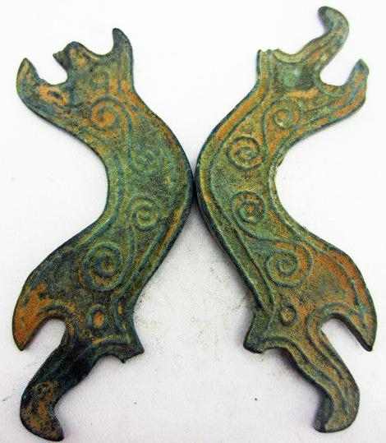

height 3 in., width 1 in., 30 gm., not in Coole 1976, vol. 5.